Install FTP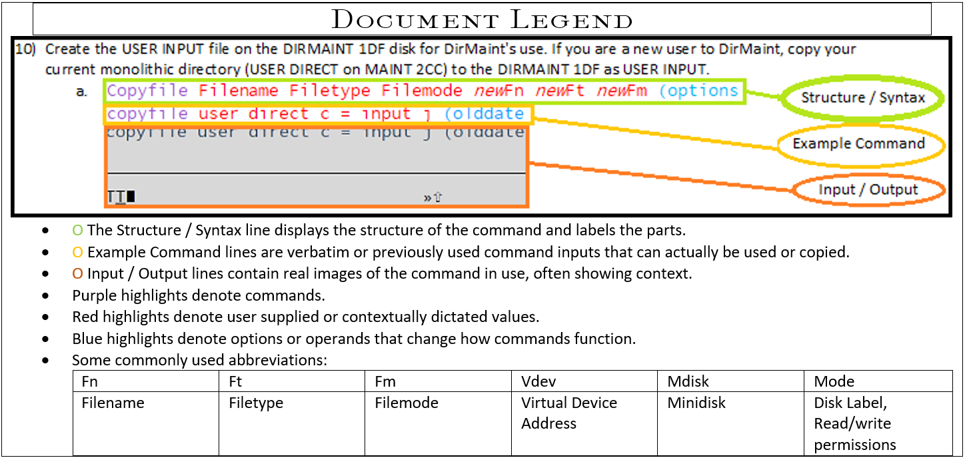

1. Log into a privileged user (one listed in the AUTHFOR CONTROL file) and establish access and write privileges to: TCPMAINT 198, 591 and 592. TCPMAINT 198 will be where the files being worked on will be filed/saved.  
   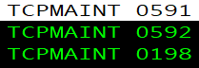
   1. Link ownerid mdisk *new*mdisk filemode  
      Link TCPMAINT 198 198 MR  
      
   2. Access mdisk filemode  
      Access 198 z  
      
   3. Link ownerid mdisk *new*mdisk filemode  
      Link TCPMAINT 591 591 WR  
      
   4. Access mdisk filemode  
      ACC 591 X  
      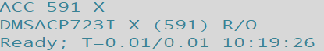
   5. Link ownerid mdisk *new*mdisk filemode  
      Link TCPMAINT 592 592 WR  
      
   6. Access mdisk filemode  
      ACC 592 W  
      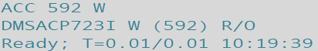
      1. Write access is only necessary for TCPMAINT 198 so the user may overwrite/save to it.
      2. TCPMAINT 591 and 592 need to be linked in order to utilize the SRVRFTP command.
   7. Confirm matching filemodes for consistent example commands:  
      Query Operand  
      Q Disk  
      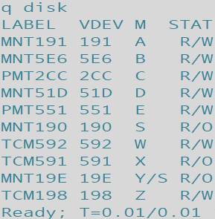
2. Pull down a copy of SRVRFTP SCONFIG for customization/editing.
   1. Copyfile FileName FileType FileMode newFN newFT newFM (options  
      COPYFILE SRVRFTP SCONFIG X = CONFIG Z  
      
3. XEdit the SRVRFTP CONFIG file, removing semicolons on desired option blocks for desired options.
   1. Xedit filename filetype filemode  
      x srvrftp config z  
      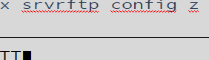
   2. Remove ; semicolon markers from the left-hand margin as shown below for desired options and or modify the statement according to its description block- these blocks have had their semicolons removed in the author’s example system:  
      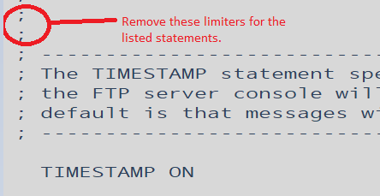

SYSTEMGREETING ON  
TRACE  
PORT 21  
PASSIVEPORTRANGE 20 21  
DONTREDIRECT  
INACTIVE 300  
SECURECONTROL NEVER  
SECUREDATA NEVER  
FTPKEEPALIVE OFF  
AUTOTRANS OFF  
LISTFORMAT VM  
TIMESTAMP ON

* 1. Save your changes by typing FILE into the xeditor command line.  
     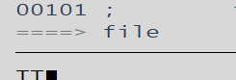

1. Remove comment markers from within TCPIP file, and add Autolog block.
   1. Xedit filename filetype filemode  
      X PROFILE TCPIP Z  
      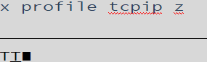
   2. Remove markers (Semicolons ;) by selecting the space they occupy and pressing <Spacebar> to overwrite the semicolon with an open space.  
      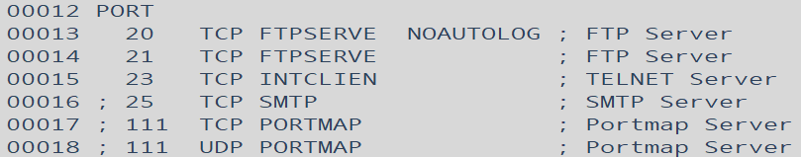
   3. If you’d like FTP enabled on IPL, add AUTOLOG block to the file, select line 7’s margin by <Clicking> the left-hand yellow text 00007 and pressing <F2> three times to add three lines then type the text shown in the red box below, respecting syntax (Spacing, line location, caps.)  
      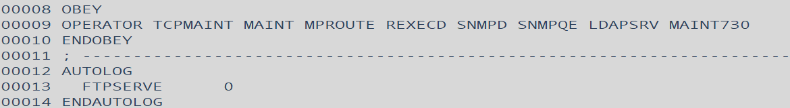
   4. File your changes by typing FILE into the xeditor command line.  
      
2. Run the srvrftp command.
   1. Srvrftp filename filetype filemode (options  
      SRVRFTP SRVRFTP CONFIG Z  
      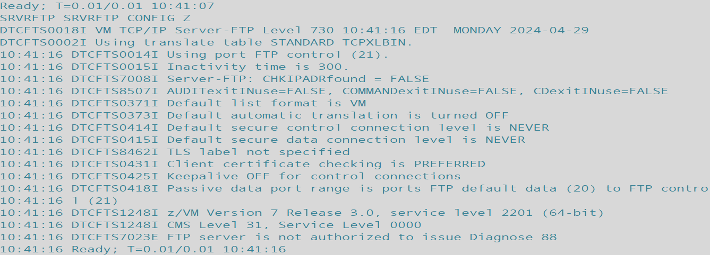
3. Command dirmaint to reload its resident operating procedures (dirm rldcode.) This should allow for autolog to bring ftpserve online disconnected.
   1. DIRM OPERAND  
      DIRM RLDC
4. Ask autolog to log FTPSERVE online disconnected to enable FTP connectivity.
   1. XAUTOLOG USERID PARAMETERS  
      XAUTOLOG FTPSERVE
5. **(\*\*\*Only necessary if FTPSERVE won’t autolog and DIRM RLDC didn’t work\*\*\*)** Shutdown and REIPL the system.
   1. SHUTDOWN operands  
      SHUTDOWN REIPL  
      